


Syrian Private University
faculty of Artificial Intelligence Engineering
Telecommunication Engineering

Project Title:

Smart Satellite Transponder

Prepared By: Supervised:

Laith AbdAlrazek Dr . Nawaf altawel

MuhammadNour Najeeb Dr . Rawad Melhem

1. Introduction to Satellite Communications

A communications satellite is an orbiting artificial earth satellite that receives a communications signal from a transmitting ground station, amplifies and possibly processes it, then transmits it back to the earth for reception by one or more receiving ground stations.
Communications information neither originates nor terminates at the satellite itself. The satellite is an active transmission.

The commercial satellite communications industry has its beginnings in the mid-1960s, and in less than 50 years has progressed from an alternative exotic technology to a mainstream transmission technology, which is pervasive in all elements of the global telecommunications infrastructure. Today’s communications satellites offer extensive capabilities in applications involving data, voice, and video, with services provided to fixed, broadcast, mobile, personal communications, and private networks users.

1.2 Satellite Communications Segments

The satellite communications portion is broken down into two areas or segments: the space segment and the ground (or earth) segment.

1.2.1 Space Segment

The elements of the space segment of a communications satellite system are shown on Figure 1.2. The space segment includes the satellite (or satellites) in orbit in the system, and the ground station that provides the operational control of the satellite(s) in orbit. The ground station is variously referred to as the Tracking, Telemetry, Command (TT&C) or the Tracking, Telemetry, Command and Monitoring (TTC&M) station. The TTC&M station provides essential spacecraft management and control functions to keep the satellite operating safely in orbit. The TTC&M links between the spacecraft and the ground are usually separate from the user communications links. TTC&M links may operate in the same frequency bands or in other bands. TTC&M is most often accomplished through a separate earth terminal facility specifically designed for the complex operations required to maintain a spacecraft in orbit.
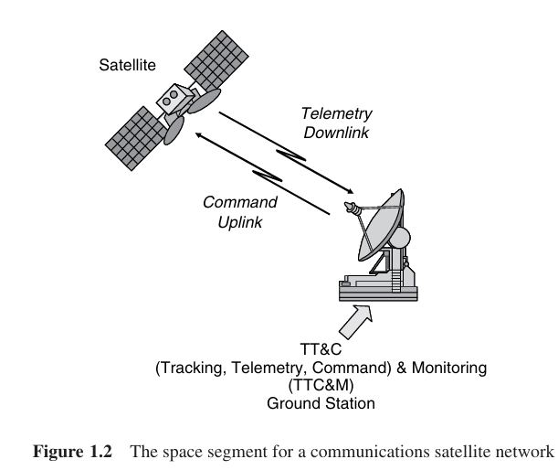

1.2.2 Ground Segment

The ground segment of the communications satellite system consists of the earth surface area based terminals that utilize the communications capabilities of the Space Segment.
ground stations are not included in the ground segment. The ground segment terminals consist of three basic types:
• fixed (in-place) terminals;
• transportable terminals;
• mobile terminals.
Fixed terminals are designed to access the satellite while fixed in-place on the ground. They may be providing different types of services, but they are defined by the fact that they are not moving while communicating with the satellite. Examples of fixed terminals are small terminals used in private networks (VSATs), or terminals mounted on residence buildings used to receive broadcast satellite signals. Transportable terminals are designed to be movable, but once on location remain fixed during transmissions to the satellite. Examples of the transportable

terminal are satellite news gathering (SGN) trucks, which move to locations, stop in place, and then deploy an antenna to establish links to the satellite. Mobile terminals are designed to communicate with the satellite while in motion. They are further defined as land mobile, aeronautical mobile, or maritime mobile, depending on their locations on or near the earth surface.

1.3 Satellite Link Parameters

The communications satellite link is defined by several basic parameters, some used in traditional communications system definitions , others unique to the satellite environment.Figure1.3 summarizes the parameters used in the evaluation of satellite communications links. Two one way free-space or air links between Earth Stations A and B are shown. The portion of the link from the earth station to the satellite is called the uplink, while the portion from the satellite to the ground is the downlink. Note that either station has an uplink and a downlink.

The electronics in the satellite that receives the uplink signal, amplifies and possibly processes the signal, and then reformat and transmits the signal back to the ground, is called the transponder, designated by the triangular amplifier symbol in the figure (the point of the triangle indicates the direction of signal transmission). Two transponders are required in the satellite for each two way link between the two ground stations as shown. The antennas on the satellite that receive and transmit the signals are usually not included as a part of the transponder electronics– they are defined as a separate element of the satellite payload.
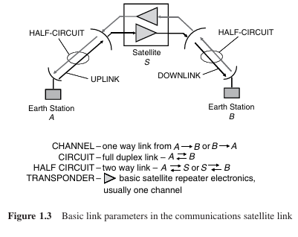

1.4 Satellite Orbits

We introduce here the satellite orbit terms for the four most commonly used orbits in satellite communications, shown in Figure 1.4. The basic orbit altitude(s) and the one-way delay times are shown for each orbit, along with the common abbreviation designations.

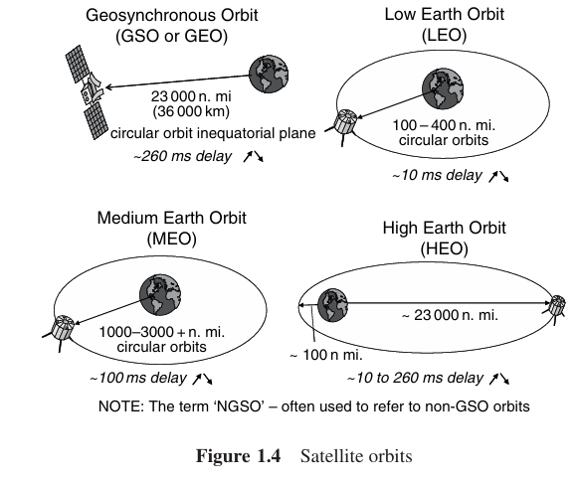

1.4.1 Geosynchronous Orbit (GSO or GEO)

The GSO orbit is by far the most popular orbit used for communications satellites. A GSO satellite is located in a circular orbit in the equatorial plane, at a nominal distance of 36000km at a stable point, which maintains the satellite at a fixed location in the sky.This is a tremendous advantage for satellite communications, because the pointing direction remains fixed in space and the ground antenna does not need to track a moving satellite. A disadvantage of the GSO is the long delay time of ∼260ms, which can affect network synchronization or impact voice communications.

1.4.2 Low Earth Orbit (LEO)

The second most common orbit is the low earth orbit (LEO), which is a circular orbit nominally 160 to 640km above the earth. The delay is low, ∼10ms, however the satellite moves across the sky, and the ground station must actively track the satellite to maintain communications.

1.4.3 Medium Earth Orbit (MEO)

The MEO is similar to the LEO, however the satellite is in a higher circular orbit– 1600 to 4200km.It is a popular orbit for navigation satellites such as the GPS constellation.

1.4.4 High Earth Orbit (HEO)

The HEO is the only non-circular orbit of the four types. It operates with an elliptical orbit , with a maximum altitude (apogee) similar to the GSO, and a minimum altitude (perigee) similar to the LEO. The HEO, used for special applications where coverage of high latitude locations is required.

Satellite orbits that are not synchronous, such as the LEO, MEO, or HEO, are often referred to as non-geosynchronous orbit (NGSO) satellites.

1.5 Frequency Band Designations

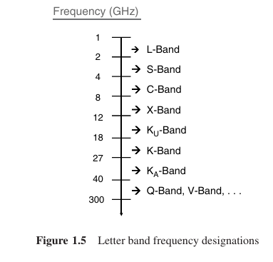
The frequency of operation is perhaps the major determining factor in the design and performance of a satellite communications link. The wavelength of the free space path signal is the principal parameter that determines the interaction effects of the atmosphere, and the resulting link path degradation. Also, the satellite systems designer must operate within the constraints of international and domestic regulations related to choice of operating free space path frequency.

- Satellite Subsystems
An operating communications satellite system consists of several elements or segments, ranging from an orbital configuration of space components to ground based components and network elements. The particular application of the satellite system, for example fixed satellite service, mobile service, or broadcast service, will determine the specific elements of the system. A generic satellite system, applicable to most satellite applications, can be described by the elements shown in Figure 3.1.
The basic system consists of a satellite (or satellites) in space, relaying information between two or more users through ground terminals and the satellite. The information relayed may be voice, data, video, or a combination of the three. The user information may require transmission via terrestrial means to connect with the ground terminal.
The satellite is controlled from the ground through a satellite control facility, often called the master control center (MCC), which provides tracking, telemetry, command, and monitoring functions for the system.

The space segment equipment carried aboard the satellite can be classified under two functional areas: the bus and the payload, as shown in Figure 3.2.
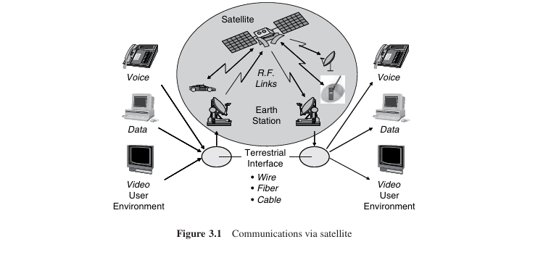

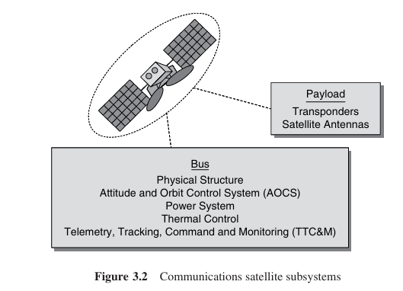

Bus The bus refers to the basic satellite structure itself and the subsystems that support the satellite. The bus subsystems are: the physical structure, power subsystem, attitude and orbital control subsystem, thermal control subsystem, and command and telemetry subsystem.

Payload The payload on a satellite is the equipment that provides the service or services intended for the satellite.
Acommunicationssatellitepayloadconsistsofthecommunications equipment that provides the relay link between the up- and down-links from the ground. The communications payload can be further divided into the transponder and the antenna subsystems.

A satellite may have more than one payload. The early Tracking and Data Relay Satellites (TDRS), for example, had an ‘Advanced Westar’ communications payload in addition to the tracking and data payload, which was the major mission of the satellite.

2.1 Satellite Payload
The next two sections discuss the key elements of the payload portion of the space segment, specifically for communications satellite systems: the transponder and antenna subsystems.

2.1.1 Antennas
The antenna systems on the spacecraft are used for transmitting and receiving the RF signals that comprise the space links of the communications channels. The antenna system is a critical part of the satellite communications system, because it is the essential element in increasing the strength of the transmitted or received signal to allow amplification, processing, and eventual re-transmission. The most important parameters that define the performance of an antenna are antenna gain, antenna beam-width, and antenna side-lobes. The gain defines the increase in strength achieved in concentrating the radio-wave energy, either in transmission or reception, by the antenna system. The antenna gain is usually expressed in dBi, decibels above an isotropic antenna, which is an antenna that radiates uniformly in all directions. The beam-width is usually expressed as the half-power beam-width or the 3-dB beam-width, which is a measure of the angle over which maximum gain occurs.The side-lobes define the amount of gain in the off-axis directions. Most satellite communications applications require an antenna to be highly directional (high gain, narrow beam-width) with negligibly small side-lobes. A detailed quantitative development of antenna parameters and their contribution to satellite link performance is provided in Chapter 4. The common types of antennas used in satellite systems are the linear dipole, the horn antenna, the parabolic reflector, and the array antenna. The linear dipole antenna is an isotropic radiator that radiates uniformly in all directions. Four or more dipole antennas are placed on the spacecraft to obtain a nearly omnidirectional pattern. Dipole antennas are used primarily at VHF and UHF for tracking, telemetry, and command links. Dipole antennas are also important during launch operations, where the spacecraft attitude has not yet been established, and for satellites that operate without attitude control or body stabilization (particularly for LEO systems). Horn antennas are used at frequencies from about 4GHz and up, when relatively wide beams are required, such as global coverage from a GSO satellite. A horn is a flared section of

wave guide that provides gains of up to about 20dBi, with beam-widths of 10◦ or higher. If higher gains or narrower bandwidths are required, a reflector or array antenna must be used. The most often used antenna for satellite systems, particularly for those operating above 10GHz, is the parabolic reflector antenna. Parabolic reflector antennas are usually illuminated by one or more horn antenna feeds at the focus of the paroboloid. Parabolic reflectors offer a much higher gain than that achievable by the horn antenna alone. Gains of 25dB and higher, with beam-widths of 1◦ or less, are achievable with parabolic reflector antennas operating in the C, Ku, or Ka bands. Narrow beam antennas usually require physical pointing mechanisms (gimbals) on the spacecraft to point the beam in the desired direction. There is increasing interest in the use of array antennas for satellite communications applications. A steerable, focused beam can be formed by combining the radiation from several small elements made up of dipoles, helices, or horns. Beam forming can be achieved by electronically phase shifting the signal at each element. Proper selection of the phase characteristics between the elements allows the direction and beam-width to be controlled, without physical movement of the antenna system.The array antenna gain increases with the square of the number of elements. Gains and beam-widths comparable to those available from parabolic reflector antennas can be achieved with array antennas.

3.2.2 Transponder
The transponder in a communications satellite is the series of components that provides the communications channel, or link, between the up link signal received at the uplink antenna, and the downlink signal transmitted by the downlink antenna. A typical communications satellite will contain several transponders, and some of the equipment may be common to more than one transponder. Each transponder generally operates in a different frequency band, with the allocated frequency spectrum band divided into slots, with a specified center frequency and operating bandwidth. The C-band FSS service allocation, for example, is 500MHz wide. A typical design would accommodate 12 transponders, each with a bandwidth of 36MHz, with guard bands of 4MHz between each. Atypical commercial communications satellite today can have 24 to 48 transponders, operating in the

C-band, Ku-band, or Ka-bands. The number of transponders can be doubled by the use of polarization frequency reuse, where two carriers at the same frequency, but with orthogonal polarization, are used. Both linear polarization (horizontal and vertical sense) and circular polarization (right-hand and left-hand sense) have been used. Additional frequency reuse may be achieved through spatial separation of the signals, in the form of narrow spot beams, which allow the reuse of the same frequency carrier for physically separate locations on the earth. Polarization reuse and spot beams can be combined to provide four times, six times, eight times, or even higher frequency reuse factors in advanced satellite systems. The communications satellite transponder is implemented in one of two general types of configurations: the frequency translation transponder and the on-board processing transponder.

3.2.2.1 Frequency Translation Transponder
The first type, which has been the dominant configuration since the inception of satellite communications, is the frequency translation transponder. The frequency translation transponder, also referred to as a non-regenerative repeater,orbent pipe, receives the uplink signal and, after amplification, retransmits it with only a translation in carrier frequency. Figure 3.8 shows the typical implementation of a dual conversion frequency translation transponder, where the uplink radio frequency, Fup, is converted to an intermediate lower frequency, Fif, amplified, and then converted backup to the downlink RF frequency,Fdwn,for transmission to earth.Frequency translation transponders are used for FSS,BSS,and MSS applications,in both GSO and NGSO orbits. The up-links and down-links are codependent, meaning that any degradation introduced on the uplink will be transferred to the downlink, affecting the total communications link. This has significant impact on the performance of the end-to-end link.

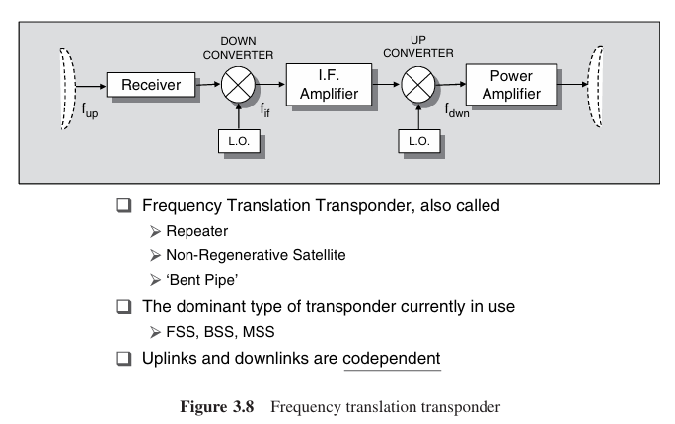
3.2.2.2 On-board Processing Transponder
Figure 3.9 shows the second type of satellite transponder, the on-board processing transponder, also called a regenerative repeater demod/re-mod transponder,or smart satellite. The uplink signal at Fup is demodulated to base-band, Fbaseband. The base-band signal is available for processing on-board, including reformatting and error-correction.The base-band information is then re-modulated to the down link carrier at Fdwn,possibly in a

different modulation format to the uplink and after final amplification,transmitted to the ground.
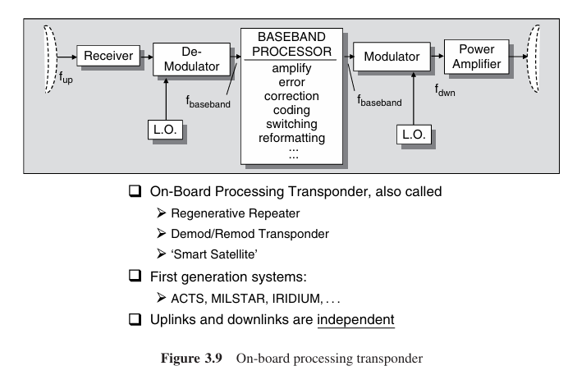
The demodulation/re-modulation process removes uplink noise and interference from the downlink, while allowing additional on-board processing to be accomplished.Thus the up-links and down-links are independent with respect to evaluation of overall link performance, unlike the frequency translation transponder where uplink degradation's are codependent, as discussed earlier.

On-board processing satellites tend to be more complex and expensive than frequency translation satellites; however, they offer significant performance advantages, particularly for small terminal users or for large diverse networks.
Traveling wave tube amplifiers (TWTAs) or solid state amplifiers (SSPAs) are used to provide the final output power required for each transponder channel. The TWTA is a slow wave structure device, which operates in a vacuum envelope, and requires permanent magnet focusing and high voltage DC power supply
support systems.
The major advantage of the TWTA is its wide bandwidth capability at microwave frequencies.
TWTAs for space applications can operate to well above 30GHz, with output powers of 150 watts or more, and RF bandwidths exceeding 1GHz. SSPAs are used when power requirements in the 2–20 watt region are required. SSPAs operate with slightly better power efficiency than the TWTA, how ever both are nonlinear devices, which directly impacts system performance, as we shall see when RF link performance is discussed in later chapters.

Other devices may be included in the basic transponder configurations of Figures 3.8 and 3.9, including band pass filters, switches, input multiplexers, switch matrices, and output multiplexers.
Each device must be considered when evaluating the signal losses and system performance of the space segment of the satellite network.

Lets dive deep
into each component
of transponder

Transponder component
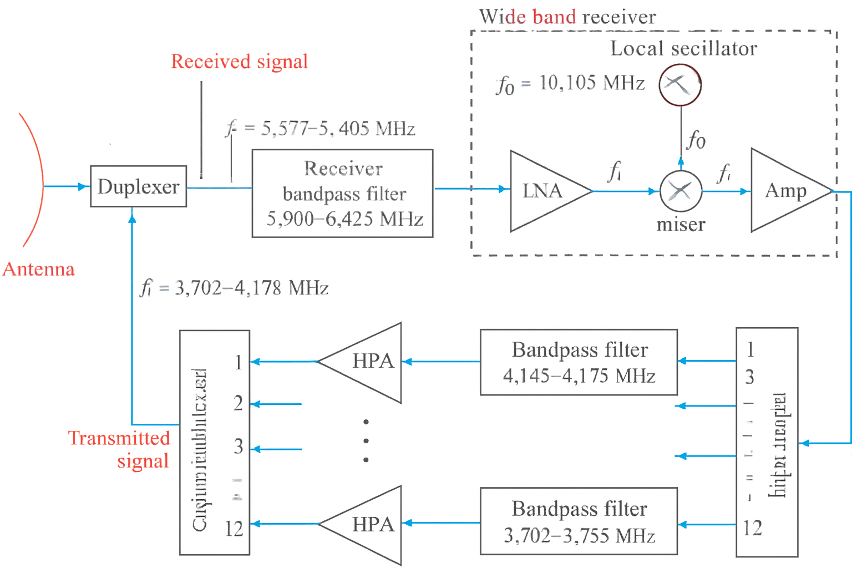
  - Duplexer
The duplexer is an RF device that allows a single antenna to be shared for both transmit and receive functions while providing isolation between the two paths so that the receiver is not damaged by the transmitter’s high power. Practically, a duplexer combines filtering, protective switching, and sometimes directional circuitry into one unit tailored to frequency band, power level, and environmental requirements.

1.1.1Duplexer Operation Modes and Types
Frequency-Division Duplexer (FDD / Diplexer)
Separates transmit and receive paths by frequency.
Implements a bandpass filter per path: each filter passes its assigned band and attenuates the other.
Common in satellite systems where uplink and downlink occupy different frequency bands.
Polarization-Division Duplexer (Orthomode Transducer)
Separates signals by polarization (e.g., RHC vs LHC or vertical vs horizontal).
Useful when dual-polarized antennas are used to double channel capacity without doubling frequency resources.
Time-Division Duplexer (TDD / TR Switch)
Separates transmit and receive by time (only transmit or receive at a given instant).
Implements TR/ATR switches or fast solid-state switches; common in radar and TDD communications.
Circulator/Isolator-Based Designs
Use non-reciprocal directional devices (circulators) to route energy: transmitter → antenna, antenna → receiver.
Provide good isolation but often require additional protection for high-power transmitters.

1.1.2Core Components of a Duplexer
Filters (Bandpass / Cavity / SAW / LC)
Allow the wanted band and reject unwanted bands.
High microwave frequencies commonly use cavity resonator or waveguide filters for high Q and power handling.
Lower-frequency or size-constrained systems may use SAW or LC filters.
Transmission Media (Coax / Waveguide / Microstrip)
Connect antenna, filters, circulators, and transceiver.
Waveguides are preferred at high microwave frequencies for lower loss and power handling.
Directional Devices (Circulators / Isolators)
Prevent reflected power from reaching sensitive stages and improve isolation.
Often ferrite-based for microwave use.
Protective Switches (TR / ATR Switches)
Protect the receiver during high-power transmit periods.
Implemented with fast solid-state switches or gas discharge tubes in some designs.
Impedance-Matching Networks
Quarter-wave transformers, stubs, or tunable elements minimize VSWR and reflections.
Mechanical Housing and Thermal Management
Robust packaging for vacuum, vibration, and temperature extremes (especially for space).
Heat sinks or conduction paths for dissipating power from transmit-side components.

1.1.3Key Design Specifications and Metrics
Isolation (dB): attenuation between transmit and receive ports; required isolation may be very high (e.g., ≥ 60 dB) in space systems.
Insertion Loss: loss introduced in the passband (must be minimal on the receive path).
Bandwidth: passband width for each filter channel.
Power Handling: maximum transmit power the duplexer can tolerate without failure or excessive distortion.
VSWR / Return Loss: degree of impedance match; poor match causes reflections and loss.
Group Delay / Phase Linearity: important for wideband and digital signals to avoid distortion of waveform timing.

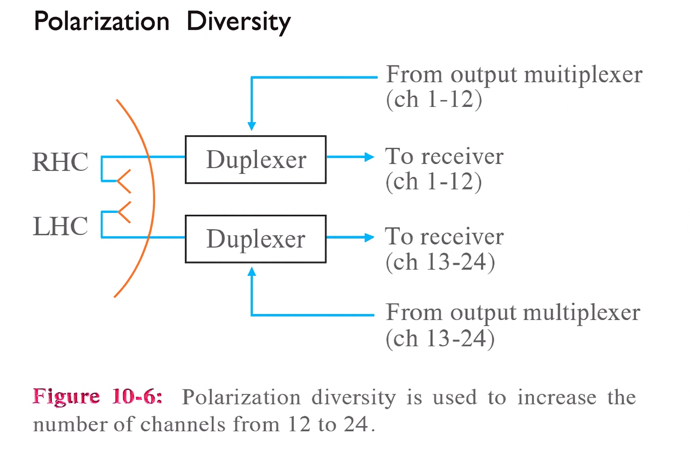
Polarization Diversity
Polarization diversity is a technique that uses two different polarization to carry independent sets of channels over the same antenna. In the example shown, the two polarization are right-hand circular (RHC) and left-hand circular (LHC). Each polarization carries its own group of channels, so by using both RHC and LHC the system can double the number of available channels without adding additional antennas or using additional frequency resources.

Shared Antenna and Dual-Polarization Element
A single shared antenna is used for both transmission and reception. Inside that antenna there is a dual-polarization element whose job is to separate the incoming and outgoing energy according to polarization. Graphically this element is often represented by two crossed elements (an “X” shape), one corresponding to the RHC polarization and the other to the LHC polarization. Physically, the dual-polarization element couples preferentially to fields that rotate clockwise (RHC) or counterclockwise (LHC) and routes those polarized signals into separate RF paths.
Signal Paths and Duplexing
Each polarization path is carried by its own RF feed line. The RHC feed line is routed through its own duplexer and handles channels 1–12, while the LHC feed line is routed through a separate duplexer and handles channels 13–24. Each duplexer performs the necessary separation of transmit and receive functions for its polarization so that the receiver front end is protected from the transmitter’s power and the two directions do not interfere with each other. The duplexers are also fed from and deliver signals to the appropriate input/output multiplexers and receivers.

Physical Principle of Polarization Separation
An electromagnetic wave can have its electric field vector rotate as it propagates; if the rotation is clockwise it is described as RHC, and if it is counterclockwise it is described as LHC. The dual-polarization element exploits this difference in rotation to separate signals: energy with clockwise rotation couples into the RHC port while energy with counterclockwise rotation couples into the LHC port. Because the two polarization are orthogonal, two independent channels at the same carrier frequency can be carried simultaneously with minimal mutual interference when the antenna, feeds and duplexers are properly designed and aligned.

Result and System Benefit
By employing polarization diversity and dedicating one polarization to channels 1–12 and the orthogonal polarization to channels 13–24, the system effectively doubles capacity from 12 channels to 24 channels using the same physical antenna aperture and the same set of frequency carriers. This approach preserves channel isolation through careful polarization control and duplexer design, enabling higher spectral efficiency without increasing antenna count or frequency allocation.

4.Digital Modulation in Satellite Communication Systems

4.1 Introduction
Digital modulation plays a fundamental role in modern satellite communication systems, particularly in achieving reliable data transmission over long distances and harsh propagation environments. With the rapid growth of satellite-based services such as digital broadcasting, broadband internet, and global navigation systems, the use of efficient digital modulation techniques has become essential.
This chapter presents a comprehensive overview of digital modulation concepts, their importance in satellite communications, and a detailed discussion of the main modulation schemes used in practical satellite systems. The selection criteria for each modulation type are also addressed in relation to system performance requirements.

4.2 Definition of Digital Modulation
Digital modulation is defined as the process of mapping digital information, represented by binary symbols (0s and 1s), onto a high-frequency carrier signal by varying one or more of its parameters, namely amplitude, frequency, or phase.
In satellite communication systems, baseband digital signals cannot be transmitted directly through free space due to attenuation and propagation limitations. Therefore, digital modulation is applied to enable efficient transmission within the allocated frequency bands.

4.3 Digital Modulation in Satellite Communication Systems
In a typical satellite communication link, digital modulation is applied at the transmitting earth station before the uplink transmission. The modulated signal propagates through space, is received by the satellite transponder, processed if required, and then retransmitted to the receiving earth station via the downlink.
The overall performance of the satellite link is strongly influenced by the selected modulation scheme, as it directly affects bandwidth efficiency, power requirements, and bit error rate performance.

4.4 Importance of Digital Modulation in Satellite Systems
The use of digital modulation in satellite communication systems provides several key advantages:
- Efficient utilization of limited frequency spectrum.
- Improved resistance to noise and interference.
- Compatibility with forward error correction techniques.
- Support for high data rate services.
- Suitability for on-board digital signal processing in smart transponders.

4.5 Digital Modulation Techniques Used in Satellite Communications.

4.5.1 Amplitude Shift Keying (ASK)
Amplitude Shift Keying is a digital modulation technique in which the amplitude of the carrier signal is varied according to the digital data. Although ASK is simple to implement, it is highly sensitive to noise and channel impairments, making it unsuitable for most satellite communication applications.
ASK is mainly used for educational purposes or very short-range communication systems.

4.5.2 Frequency Shift Keying (FSK)
In Frequency Shift Keying, digital data is represented by different carrier frequencies. FSK offers better noise immunity than ASK but requires a wider bandwidth.
In satellite systems, FSK is typically used in low-data-rate applications such as telemetry, tracking, and command (TT&C) links.

4.5.3 Binary Phase Shift Keying (BPSK)
Binary Phase Shift Keying is one of the most robust digital modulation techniques. It represents digital data by shifting the phase of the carrier signal between two states separated by 180 degrees.
BPSK provides excellent performance in low signal-to-noise ratio environments and is widely used in satellite systems where reliability is prioritized over data rate.

4.5.4 Quadrature Phase Shift Keying (QPSK)
QPSK is an extension of BPSK that transmits two bits per symbol by using four distinct phase states. This doubles the data rate without significantly increasing power requirements.
QPSK is extensively used in satellite broadcasting standards such as DVB-S and DVB-S2 due to its balanced performance between spectral efficiency and noise tolerance.

4.5.5 Higher-Order PSK and QAM
Higher-order modulation schemes such as 8PSK and Quadrature Amplitude Modulation (QAM) enable higher data rates by increasing the number of symbols. However, these schemes require higher signal-to-noise ratios and are more sensitive to non-linear distortions in satellite power amplifiers.
These modulation techniques are commonly used in high-throughput satellite systems where channel conditions are favorable.

4.6 Modulation Selection Criteria in Satellite Systems
The selection of an appropriate modulation scheme depends on several factors, including available bandwidth, transmit power, signal-to-noise ratio, type of service, and satellite transponder architecture.
Lower-order modulation schemes are preferred in noisy environments, while higher-order schemes are used when higher data rates are required and channel conditions permit.

4.7 Digital Modulation and Smart Satellite Transponder
In smart satellite transponders, the received uplink signal is demodulated to baseband, processed digitally, and then remodulated for downlink transmission. This approach allows independent optimization of uplink and downlink modulation schemes, leading to improved system performance and flexibility.

References:
Louis J. Ippolito, Jr. ITT Advanced Engineering & Sciences, USA, and The George Washington University, Washington, DC, USA.
Dennis Roddy,
Satellite Communications,
4th Edition, McGraw-Hill Education, 2006.

Contents
Project Title: 1
Prepared By: Supervised: 1
Laith AbdAlrazek Dr . Nawaf altawel 1
MuhammadNour Najeeb Dr . Rawad Melhem 1
1. Introduction to Satellite Communications 2
1.2 Satellite Communications Segments 3
1.3 Satellite Link Parameters 6
1.4 Satellite Orbits 9
1.5 Frequency Band Designations 13
2. Satellite Subsystems 14
2.1 Satellite Payload 18
3.2.2 Transponder 21
1.1.1Duplexer Operation Modes and Types 29
1.1.2Core Components of a Duplexer 31
1.1.3Key Design Specifications and Metrics 32
4.Digital Modulation in Satellite Communication Systems 36
4.1 Introduction 36
4.2 Definition of Digital Modulation 36
4.3 Digital Modulation in Satellite Communication Systems 37
4.4 Importance of Digital Modulation in Satellite Systems 37
4.5 Digital Modulation Techniques Used in Satellite Communications 38
4.6 Modulation Selection Criteria in Satellite Systems 39
4.7 Digital Modulation and Smart Satellite Transponder 40

